Module 4: Group Products

Lesson 2: Group Life Insurance

Learning Objectives

After studying this lesson, you will be able to:
- Identify and describe typical eligibility requirements included in group life insurance contracts.
- Identify the person who is entitled to name the beneficiary of group life insurance coverage.
- Describe the grace period provision and the incontestability provision typically included in group life insurance contracts.
- Identify situations in which a group member’s group life insurance coverage terminates, and describe the group insured’s conversion rights in these situations.
- Describe the purpose and operation of benefit schedules in group life insurance policies.
- Identify the features of group term life insurance plans, group accidental death and dismemberment plans, and group cash value plans.
- Describe how group creditor life insurance policies differ from policies issued to other types of groups.

Group Life Insurance

Learning Objective
Identify and describe typical eligibility requirements included in group life insurance contracts.
Open Transcript

Eligibility Provisions

Every group insurance policy has provisions identifying the people who are eligible for group insurance coverage.
A group policy for an employee group specifies the classes of employees who are eligible for coverage.

Employers can specify many different types of employee classes as eligible for group insurance coverage. Of the following descriptions of employee classes, which one do you think might violate United States law?
Employees who make at least $20,000 annually
Employees who have worked for a specified period, such as for at least 3 months
Employees in identified occupations
Employees who are full-time workers age 45 and younger

Eligibility
According to The Stetson Company’s group life insurance policy, only full-time employees are eligible for coverage.
Full-time employment is a standard eligibility requirement for policies that insure employee groups. Some policies may offer benefits (or reduced benefits) for part-time employees.
Open Transcript

Probationary Period
Many group policies require a group member to work full time for a probationary period before becoming eligible for coverage.
For example, Jerome’s company, The Stetson Company, has a three month probationary period for its group life policy.
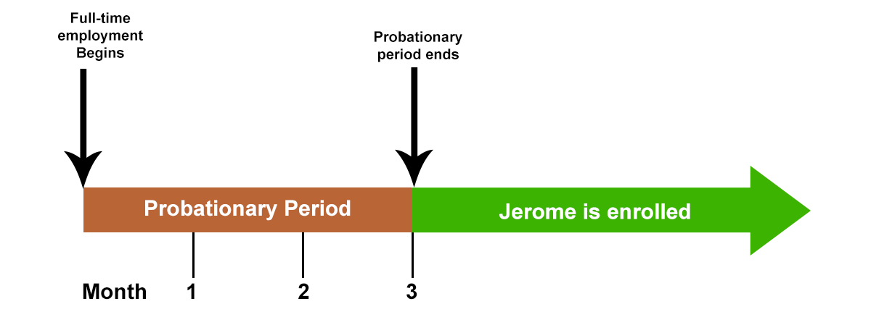
Jerome must work full-time for a probationary period of three months before he is entitled to enroll in the Stetson Company’s group coverage.

Once Jerome completes the probationary period, he will automatically be covered under Stetson’s group life insurance plan. That means the group life plan is a
^{Contributory plan}
^{Noncontributory plan}

Eligibility Period
So what happens with a contributory plan?
Here’s an example of a contributory plan with a 3-month probationary period.
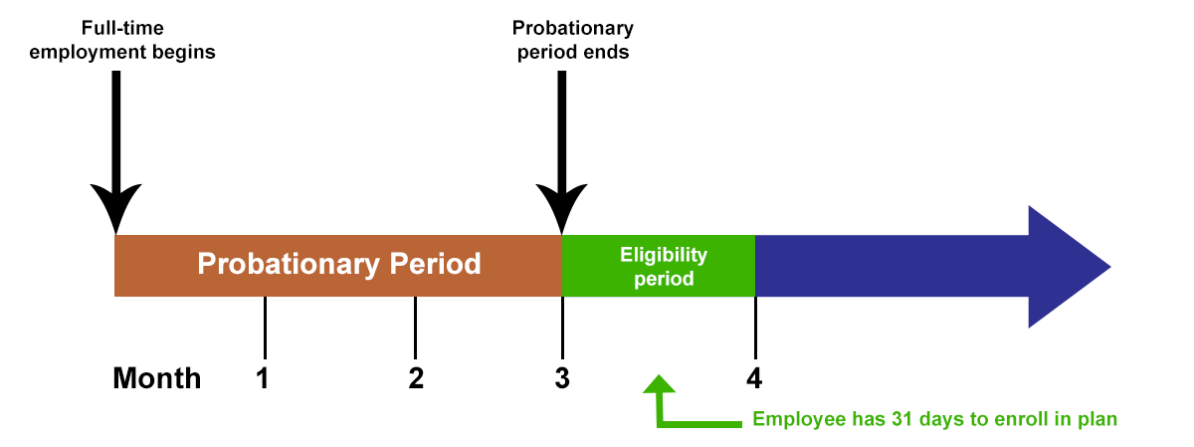
Image Description
Following the probationary period is an eligibility period (enrollment period), which gives an eligible group member 31 days to enroll, without having to provide evidence of insurability.

Enrollment
To enroll in a contributory plan, an eligible employee signs a form that authorizes the employer to deduct premium payments from the employee’s pay.

Maggie Bell did not sign up for her company’s contributory group life insurance plan during the enrollment period. Six months after the deadline, Maggie decided to enroll. What requirements do you think Maggie will have to meet? (Choose all that apply.)
Provide satisfactory evidence of her insurability
Complete an enrollment form that authorizes payroll deductions
Pay all back premiums from her eligibility date to her enrollment date
Submit

Myrna Kane is starting a new job on March 1 and she’ll have group life insurance coverage after she’s worked full-time for 1 month. The one-month waiting period is known as the
^{Eligibility period}
^{Probationary period}
If Myrna’s group insurance coverage is contributory, she must enroll for the coverage within a certain period of time to avoid providing evidence of insurability.
^{True}
^{False}

Actively-at-Work Provision

Assume that Jerome has been working full-time for three months. However, he broke his leg and was out on leave on the day that he was eligible for coverage under Stetson’s group life insurance plan.

Open Transcript
The Stetson Company’s group life insurance policy contains an actively-at-work provision that requires an eligible employee to be at work—not on leave or out sick—on the day coverage is to take effect.

If the employee is not actively at work on that day, the group insurance coverage takes effect the next day that the employee is actively at work.

On July 1, Ray Tobin became an employee of Draco International. Draco’s group life insurance policy has a 3-month probationary period. Mr. Tobin would have been eligible for coverage on October 1st. However, he was ill and out of the office for two weeks. He returned to work full-time on October 15th. Draco’s group life insurance policy contains an actively-at-work provision.

The earliest date on which Mr. Tobin’s group life insurance coverage will be effective is
^{July 1}
^{October 1}
^{October 15}

Dependent Coverage
Group life insurance policies often cover dependents (spouse and dependent children) of covered group members.
Let’s look at Stetson’s group life insurance policy, which offers coverage to Jerome’s dependents.

Group Contract Provisions

Learning Objective
Identify the person who is entitled to name the beneficiary of group life insurance coverage.
Describe the grace period provision and the incontestability provision typically included in group life insurance contracts.

Once he meets the policy’s eligibility requirements, Jerome will have $50,000 of group life insurance and his wife will have $10,000 of insurance. Who do you think names the beneficiary for each of their coverages?
Jerome names the beneficiary of his coverage and is the beneficiary of his wife’s coverage.
Jerome names the beneficiary of his coverage, and Jerome’s wife names the beneficiary of her coverage.

Grace Period Provision
Like individual insurance policies, group policies have a grace period provision to help keep policies in force.
Because group premiums are usually paid monthly, the grace period usually is 31 days.

Grace Period
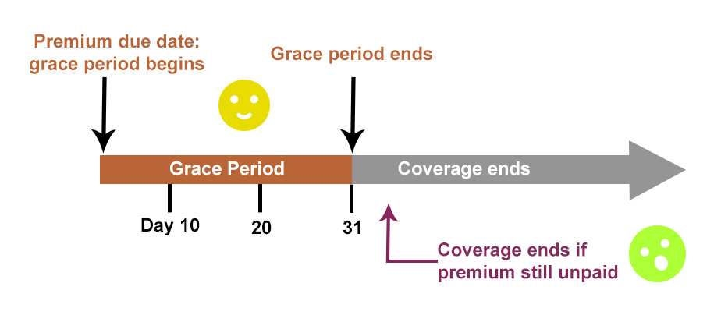
Image Description
If a premium isn’t paid by its due date, coverage continues throughout the grace period. The policy terminates if the premium isn’t paid by the end of the grace period.

When the policyholder pays a premium during the grace period, the insurer is paid for the coverage it provided during the grace period.

But if the policy terminates for nonpayment of premium, is the insurer owed the premium for coverage provided during the grace period?
Yes. A group policyholder is legally obligated to pay for the grace period coverage.
No. The policyholder is not legally required to pay for the grace period coverage.

Incontestability Provision

Like individual insurance policies, group insurance policies contain an incontestability provision. The contestable period usually runs for two years from the date of policy issue.
This provision limits the time during which the insurer may use statements in the group insurance application to contest the validity of the contract. Material misrepresentation occurs infrequently in group insurance applications.

Group Insurance Application
The group incontestable provision also allows the insurer to contest an individual group member’s coverage on the basis of material misrepresentations made by the group member.
Eligible group members usually enroll for coverage without answering questions about their insurability.
But sometimes an eligible group member completes an application and provides evidence of insurability.
Who must provide evidence of insurability?

Evidence of Insurability

Those who must provide evidence of insurability:
- All eligible group members of a very small group applying for coverage
- A person enrolling in a contributory plan after the eligibility period
- A person who applies for more insurance coverage than the standard offering, or who applies for available supplemental coverage

Group Underwriting
See as this industry expert explains how group underwriting will use medical underwriting in order to obtain more accurate premium rates for a given group.
Open Transcript

Open Transcript

Incontestability Provision
When a group insured has made a material misrepresentation, the insurer can contest the validity of that person’s coverage within a specified period, usually one or two years, after the coverage goes into effect.
The group insurance contract remains valid and in force.

Mary Price enrolled for her employer’s contributory group life insurance plan after the end of the eligibility period. Was she required to provide the insurer with evidence of insurability?
^{Yes}
^{No}
Can’t tell; need more information
In the health questionnaire that Mary Price completed to obtain the group life insurance, she misrepresented her health in a way that was material to the risk. Mary died one year later and the insurer discovered the misrepresentation. The group policy contained a two-year contestable period. The insurer can contest the validity of
Mary’s coverage, but not the group insurance contract
Both Mary’s coverage and the group insurance contract
Neither the group insurance contract nor Mary’s coverage

Insurance Termination and Conversion

Learning Objective
Identify situations in which a group member’s group life insurance coverage terminates, and describe the group insured’s conversion rights in these situations.

Loss of Coverage

A person insured by a group life insurance policy can lose that coverage if
- The group policy terminates
- The person is no longer eligible for group coverage

Termination of the Group Policy

According to the terms of most group insurance policies, the group policyholder may terminate the policy at any time by notifying the insurer in writing.
The insurer may also have the right to terminate the group insurance policy on any premium due date if certain conditions exist.
What kind of conditions?

Participation Level
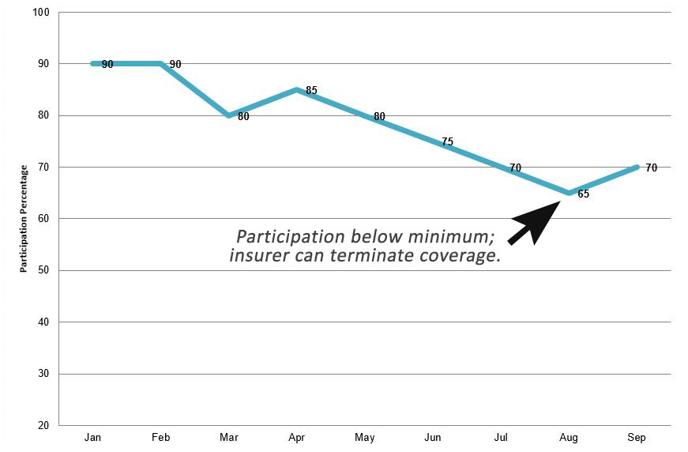
If the group’s participation level falls below the required minimum, the insurance company has the right to terminate the policy.

Termination of a Group Insured’s Coverage

Most group insurance policies provide that a group insured’s coverage terminates in the following circumstances:
- If the group insured ceases to be a member of a class of persons eligible for coverage.
• If the group insured ceases to be a member of a class of persons eligible for coverage.
Examples
Olive Murphy had been insured as a dependent under her father’s group insurance policy. Olive just turned 21 years old and is no longer financially dependent on her father.
Harry Towne had been insured under his employer’s group insurance plan. Harry’s job classification changed to a part-time employee, which is not eligible for group insurance coverage.
• If the group insured terminates employment or group membership
Examples
Kamie Ellison, who had been insured under her employer’s group insurance policy, quit her job.
Jeff Oslo had been insured under a group creditor insurance plan issued to the Pine Bank. Jeff recently paid off the credit card debt he owed the bank, and he canceled the credit card account.
• If the group insured fails to make a required contribution to the premium
Example
Carlos Land had been insured under his employer’s contributory group insurance policy. Carlos withdrew his authorization for his employer to deduct premiums from his pay.

Conversion Privilege
Laws in many jurisdictions require that group insurance contracts contain a conversion privilege that allows a group insured to convert his group life coverage to individual coverage in certain situations.
No evidence of insurability is required.
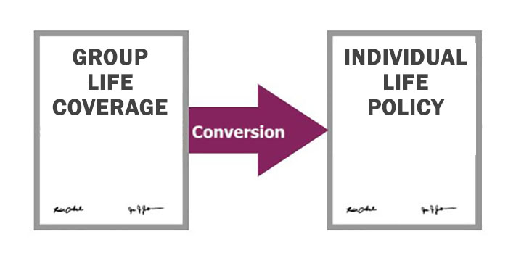


Limitations on Conversion
Laws in many jurisdictions limit the conversion privilege in the following ways. (Click or touch each tab below.)
Who?
How much?
When?

Conversion Privilege
A conversion privilege may be more favorable to group insureds than the minimum required by laws.
Example: A group policy might state that, when a group insured’s coverage ends, he may convert up to the amount of insurance he had under the group contract. This example is more generous than the amount required by law.

Plan of Individual Insurance

Usually, a group insured can purchase any type of individual life insurance policy that the insurer issues.
The cost of converted coverage is the insurer’s standard premium rate for that type of policy at the group insured’s sex and attained age.
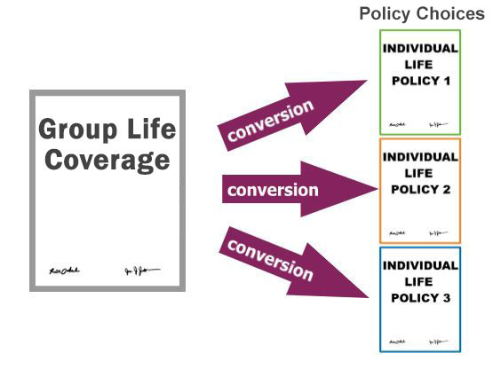

Zara Chugne, age 30, left her job at the Plentiful Company. One week later, she started a new job at Excel Services. She’d like to convert her Plentiful group life insurance to an individual policy. Select each true statement about this situation. (Choose all that apply)
Zara is still within the conversion period for Plentiful’s group life policy.
Zara will have to provide evidence of insurability to convert her Plentiful group coverage to an individual policy.
If Zara converts her Plentiful coverage, the premium rate she will pay for the individual policy will be the same premium rate she paid for her group coverage.

Insurance Termination and Conversion

Learning Objective
Identify situations in which a group member’s group life insurance coverage terminates, and describe the group insured’s conversion rights in these situations.

Loss of Coverage

A person insured by a group life insurance policy can lose that coverage if
- The group policy terminates
- The person is no longer eligible for group coverage

Termination of the Group Policy

According to the terms of most group insurance policies, the group policyholder may terminate the policy at any time by notifying the insurer in writing.
The insurer may also have the right to terminate the group insurance policy on any premium due date if certain conditions exist.
What kind of conditions?

Participation Level

If the group’s participation level falls below the required minimum, the insurance company has the right to terminate the policy.

Termination of a Group Insured’s Coverage

Most group insurance policies provide that a group insured’s coverage terminates in the following circumstances:
- If the group insured ceases to be a member of a class of persons eligible for coverage.
• If the group insured ceases to be a member of a class of persons eligible for coverage.
Examples
Olive Murphy had been insured as a dependent under her father’s group insurance policy. Olive just turned 21 years old and is no longer financially dependent on her father.
Harry Towne had been insured under his employer’s group insurance plan. Harry’s job classification changed to a part-time employee, which is not eligible for group insurance coverage.
• If the group insured terminates employment or group membership
Examples
Kamie Ellison, who had been insured under her employer’s group insurance policy, quit her job.
Jeff Oslo had been insured under a group creditor insurance plan issued to the Pine Bank. Jeff recently paid off the credit card debt he owed the bank, and he canceled the credit card account.
• If the group insured fails to make a required contribution to the premium
Example
Carlos Land had been insured under his employer’s contributory group insurance policy. Carlos withdrew his authorization for his employer to deduct premiums from his pay.

Conversion Privilege
Laws in many jurisdictions require that group insurance contracts contain a conversion privilege that allows a group insured to convert his group life coverage to individual coverage in certain situations.
No evidence of insurability is required.



Limitations on Conversion
Laws in many jurisdictions limit the conversion privilege in the following ways. (Click or touch each tab below.)
Who?
How much?
When?

Conversion Privilege
A conversion privilege may be more favorable to group insureds than the minimum required by laws.
Example: A group policy might state that, when a group insured’s coverage ends, he may convert up to the amount of insurance he had under the group contract. This example is more generous than the amount required by law.

Plan of Individual Insurance

Usually, a group insured can purchase any type of individual life insurance policy that the insurer issues.
The cost of converted coverage is the insurer’s standard premium rate for that type of policy at the group insured’s sex and attained age.


Zara Chugne, age 30, left her job at the Plentiful Company. One week later, she started a new job at Excel Services. She’d like to convert her Plentiful group life insurance to an individual policy. Select each true statement about this situation. (Choose all that apply)
Zara is still within the conversion period for Plentiful’s group life policy.
Zara will have to provide evidence of insurability to convert her Plentiful group coverage to an individual policy.
If Zara converts her Plentiful coverage, the premium rate she will pay for the individual policy will be the same premium rate she paid for her group coverage.

Benefit Amounts

Learning Objective
Describe the purpose and operation of benefit schedules in group life insurance policies.

Open Transcript

Benefit Schedules

A benefit schedule shows how much group life insurance coverage each group insured receives.
The benefit schedule states either the dollar amount of coverage or the method the insurer will use to determine that dollar amount.

Three Common Types of Benefit Schedules for Employee Groups

Benefit formula based on annual salary
Annual Salary | Amount of life insurance
Less than $60,000 | 1 x salary
$60,000 to $100,000 | 2 x salary
Over $100,000 | 3 x salary

Benefit is a flat amount for every employee
Annual Salary | Amount of life insurance
Any | $50,000

Benefit amount based on job classification
Annual Salary | Amount of life insurance
Nonmanagement | $30,000
Supervisors | $50,000
Managers | $100,000
Officers | $200,000

Dependent Coverage Amounts
Dependent coverage amounts are listed in a separate benefit schedule.
Examples:
- A flat amount of coverage for each covered dependent.
- A flat amount of coverage for a group member’s spouse and a lower amount for each dependent child.
Some insurance laws—and insurer underwriting guidelines—require that dependent coverage be less than the covered group member’s coverage.

The Daisy Company offers group life insurance to its 100 employees as part of its employee benefit plan. The table below presents information about two employee who work at Daisy:

Group Life Insurance
Employee | Job Title | Age | Salary | Employed | Amount of Life Insurance | Dependents
John Warren | Manager | 60 | $80,000 | 8 years | $160,000 | Spouse
Todd Addison | Welder | 24 | $25,000 | 3 years | $25,000 | None
The benefit schedule in Daisy's group life insurance policy is based on
^{A standard flat amount}
^{An employee's annual salary}
Can’t tell; need more information
If Daisy's policy is typical, then the amount of coverage provided for John's wife is
Greater than the amount of coverage provided for John
Less than the amount of coverage provided for John

Settlement Options
Usually, insurers pay group life insurance policy death benefits in a lump sum to the named beneficiary. But some group policies allow a beneficiary to choose a settlement option.
The settlement options are the same as those in individual policies (click or touch each tab to review that settlement option):
Lump-sum option: The insurer pays the proceeds in a single payment.

Interest option: The insurer invests the policy proceeds and periodically pays interest on the proceeds.
Fixed-period option: The insurer pays the policy proceeds in equal installments for a specified period of time.
Fixed-amount option: The insurer pays equal installments of a stated amount until the policy proceeds, plus the interest earned, are exhausted.
Life income option

Features of the Group Plans

Learning Objective
Identify the features of group term life insurance plans, group accidental death and dismemberment plans, and group cash value plans.
Describe how group creditor life insurance policies differ from policies issued to other types of groups.

Yearly Renewable Term Insurance
Like most group life policies, The Stetson Company’s policy is yearly renewable term (YRT) insurance. The coverage lasts for one year.
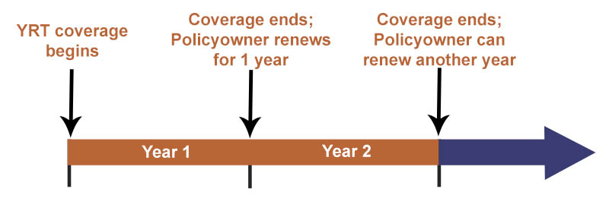
Group YRT policies do not build cash values.
The insurer can change the premium rate at the end of each policy year.
Typically, an employee can receive up to $50,000 of noncontributory group term insurance coverage tax free. An employee must pay federal income taxes on the employer's cost of providing coverage over $50,000.

Open Transcript

AD&D Benefits
A group policy may provide accidental death and dismemberment (AD&D) benefits. Or a group policyholder may have separate group life and group AD&D policies.
Jerome’s group life coverage includes a $50,000 accidental death benefit. If he dies as the result of an accident, the named beneficiary will receive
$50,000 YRT + $50,000 AD&D = $100,000

Cash Value Insurance
Some group life policies provide cash value insurance rather than YRT coverage.
Usually, cash value life insurance is supplemental coverage. Eligible group members have the option to buy cash value insurance in addition to their group YRT coverage.

Cash Value Plans

Three common types of group cash value (permanent) life insurance plans:
- Group Paid-Up
- Group Level-Premium Whole Life
- Group Universal Life

Group Paid-Up Plans
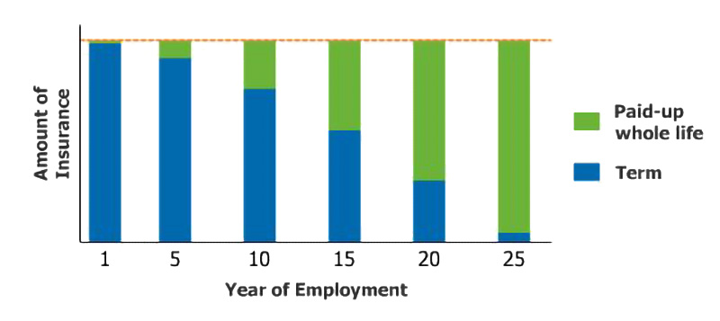
Group paid-up plans combine whole life insurance with decreasing amounts of term life insurance.

Group Paid Up Plan Example
Ben Song has $100,000 of total life insurance coverage through a contributory group paid-up plan.
Ben’s premiums purchase paid-up whole life insurance. His employer’s premiums purchase YRT life insurance. Last year, Ben’s premiums purchased $10,000 of paid-up whole life. Ben’s employer paid for $90,000 of YRT.
Over time, as his paid-up whole life insurance coverage increases, the amount of his YRT coverage decreases. Together, Ben will always have $100,000 of coverage. Ben’s paid-up whole life coverage remains in force even if he leaves the company.

Group Level Premium Whole Life Plans
Group level premium whole life plans provide level premium whole life insurance.
The plan can be contributory or noncontributory. If the employee contributes, she has a vested right in the amount of the cash value provided by her premium contributions.


Group Level Premium Whole Life Example
Violet Young is insured by a noncontributory group level premium whole life insurance policy. Her whole life coverage will be paid-up at age 65, her normal retirement age.
At retirement, her employer will use the cash value of her paid-up coverage to provide her a retirement income.
If Violet leaves the group before her retirement, her group life insurance coverage will terminate and any accumulated cash value belongs to her employer.
If the policy had been contributory, and Violet had left the group before retirement, she would be entitled to a portion of the accumulated value. For example, if she had paid 25 percent of the premiums for the coverage, she would be entitled to 25 percent of the accumulated value.

Group Universal Life Plans

Group universal life plans provide universal life insurance and covered group members usually pay the entire premium.

Group Universal Life Example
Walt Hart’s employer provides a group universal life insurance plan that operates much like an individual universal life insurance policy. Walt chooses the premium amount he wants to pay, which affects the amount of the policy’s cash value.
Walt’s coverage is portable; if he leaves his job, he can continue his coverage under the group plan.

Group Creditor Life
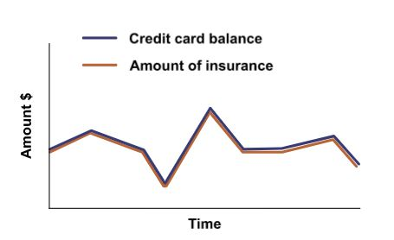
Jerome has a credit card issued by the Swift Bank. Jerome is insured under Swift’s group creditor life insurance policy.
At any time, the amount of insurance Jerome has on his life equals the amount he owes on the credit card account.

Does Jerome get to name the beneficiary of his group creditor life insurance coverage through Swift Bank?
^{Yes}
^{No}

Pat McLain is covered under a noncontributory group life insurance plan offered by his employer, The Chestnut Company. Chestnut's policy provides Pat with $100,000 of group term life insurance. Does Pat have to pay federal income taxes on any of Chestnut’s cost for providing his coverage?
No, group life insurance benefits are never taxable.
Yes, Pat must pay federal income taxes on Chestnut’s cost of providing $50,000 of coverage.
Yes, Pat must pay federal income taxes on Chestnut’s cost of providing $100,000 of coverage.
Sean Cranston is covered under a typical group paid-up life insurance plan through his employer, The Neptune Company.

Neptune’s group plan combines paid-up whole life insurance with
Decreasing amounts of term life insurance
Increasing amounts of term life insurance
If Sean retires or leaves the group, his paid-up whole life coverage will
^{Terminate}
^{Remain in force}
Emily Thompson signed up for the group universal life insurance plan offered by her employer, the Dayshore Company.

If this plan is typical, who pays the premiums for Emily’s coverage?
^{Emily}
^{Dayshore}
Is Emily’s UL coverage portable?
^{Yes}
^{No}

